**Team Project Report**

**Team Members**

Brandon Cole, Rami, Michael Lee, Lysian Mve, Adelia Manuel

**Team Model**

Our team has adopted the chief programmer team. We decided on this model as most suitable for the LearnHub project as everyone has conflicting schedules. So it allows us to delegate roles and meet up when finished with flowing deadlines. The life cycle is the rapid prototype lif

Brandon Cole - Chief Programmer

Rami - Frontend Developer, Quality Assurance

Michael Lee - Backend Developer, Quality Assurance

Adelia Manuel - Backend Developer, Documentation Assistant

Lysian Mve - Frontend Developer, Documentation Assistant

**Diagrams**

**Entity Relation Diagram**

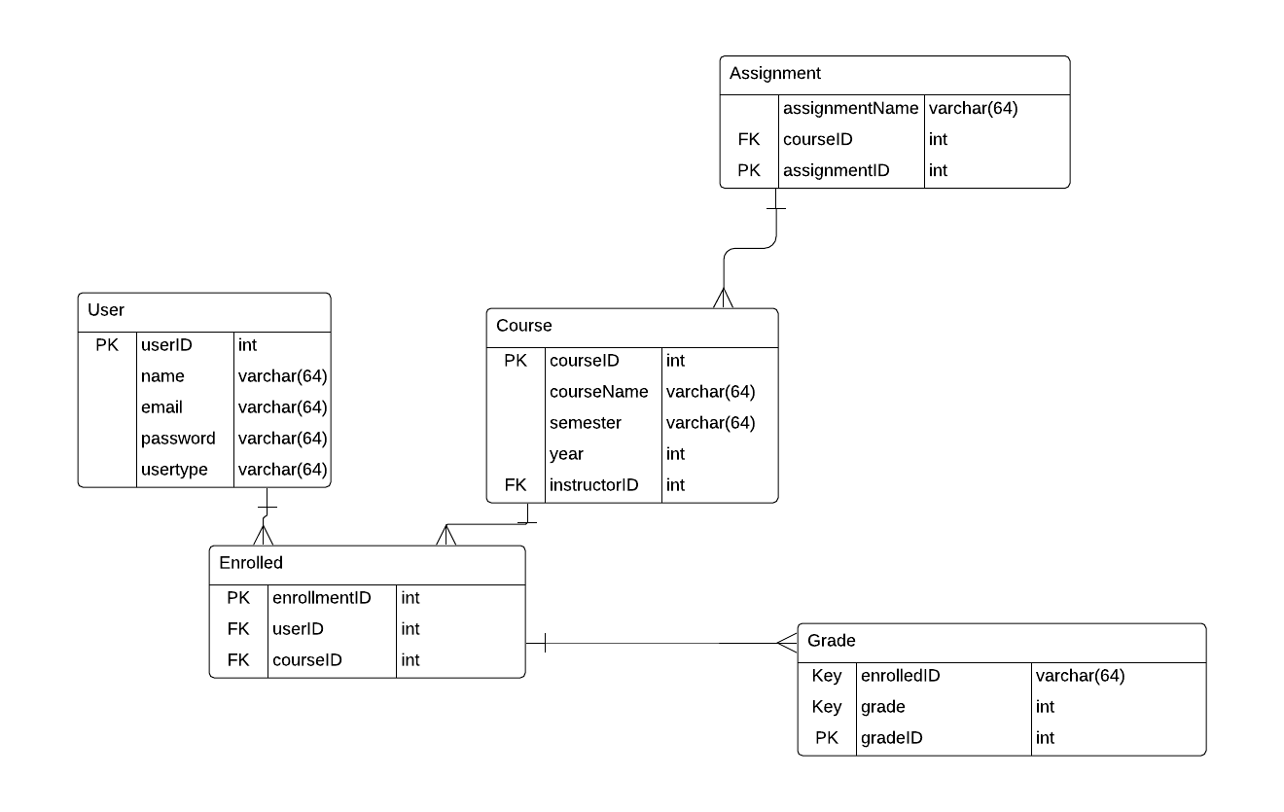

**Use Case Diagram**

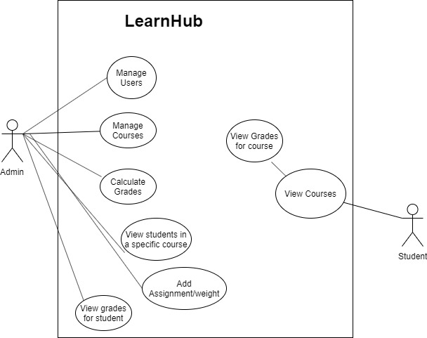

**Class Diagram**

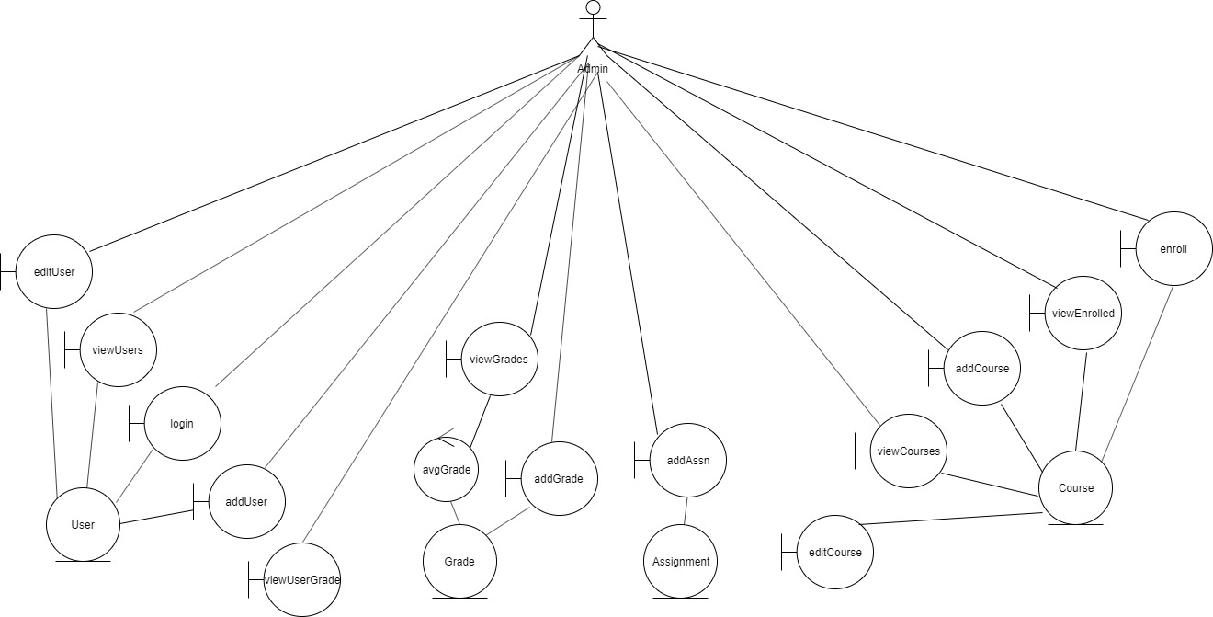

**Architecture Diagram**

